**Introduction to Statistical Methods**

**(S2-22_AIMLCZC418– Assignment 2)**

**AIML – Section – 2**

1. The masses of cucumbers grown at a smallholding are normally distributed with mean 310 g and standard deviation 22 g. Producers of a new plant food claim that its use increases the masses of cucumbers. To test this claim, some cucumber plants are grown using the new plant food and a random sample of 40 cucumbers from these plants are selected and weighed. The mean mass of these cucumbers is 316 g. Assuming the standard deviation of the masses of the sample is the same as the standard deviation of the population, test the claim at 5% level of significance.

Solution:

                         H0 : = 310

                        H1 :> 310

One tailed test at 5% level of significance

Critical value z is 1.645

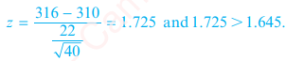

Z calculated= 1.725, 1.725 > 1.645

Reject H0 and accept H1

1. To verify whether a course in accounting improved performance a similar test was given to 12 participated both before and after the course. The marks are :

|  |  |  |  |  |  |  |  |  |  |  |  |  |
| --- | --- | --- | --- | --- | --- | --- | --- | --- | --- | --- | --- | --- |
| Before | 44 | 40 | 61 | 52 | 32 | 44 | 70 | 41 | 67 | 72 | 53 | 72 |
| After | 53 | 38 | 69 | 57 | 46 | 39 | 73 | 48 | 73 | 74 | 60 | 78 |

Was the course useful?

Solution:

H0 : There is no significant difference in accounting performance before and after course

H1 : There is significant difference in accounting performance before and after course.

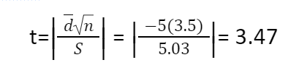

Degree of freedom =11

Table value=2.201, tcalculated >Table value,H0 is rejected

1. The following table gives the number of good and bad parts produced by each of three shifts in a factory

|  |  |  |
| --- | --- | --- |
| **SHIFTS** | **GOOD** | **BAD** |
| DAY | 900 | 130 |
| EVENING | 700 | 170 |
| NIGHT | 400 | 200 |

Test if there is any association between shifts and quality at 5%.

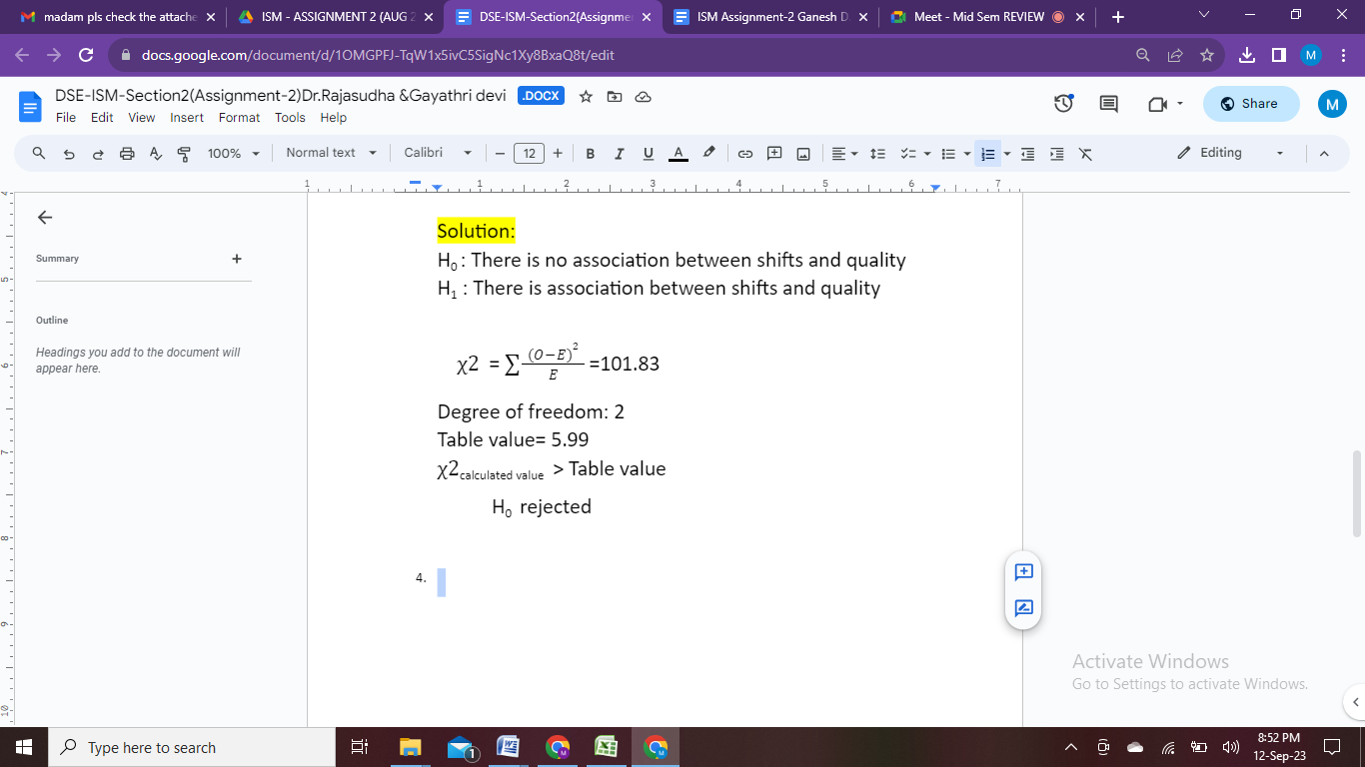

1. The times required by three workers to perform an assembly-line task were recorded on five randomly selected occasions. Here are the times, to the nearest minute.

|  |  |  |
| --- | --- | --- |
| Hank | Joseph | Susan |
| 8 | 8 | 10 |
| 10 | 9 | 9 |
| 9 | 9 | 10 |
| 11 | 8 | 11 |
| 10 | 10 | 9 |

Construct one-way Anova

table for the given data.

Solution:

